LOYOLA COLLEGE (AUTONOMOUS), CHENNAI – 600 034
M.A. DEGREE EXAMINATION - ENGLISH LITERATURE
FOURTH SEMESTER – APRIL 2012

EL 4952 - TRANSLATION

Date : 25-04-2012 Dept. No. Max. : 100 Marks

Time : 1:00 - 4:00

SECTION - A

I Answer any FOUR of the following in about 100 words each: (4x5=20)

1) Interlingual and intralingual translation
- Types of translation.
- History of translation
- Translation equivalences.
- Translation of poetry
- Responsibilities of a translator

II Answer any THREE of the following in about 250 words each: (3x10=30)

- Culture and translation
- Untranslatability in Translation
- Translation in ELT
- Translation problems and solutions
- Technical translation
- Translation and sociolinguistics

SECTION – B
Translate any Ten of the following: 10 x 5 =50

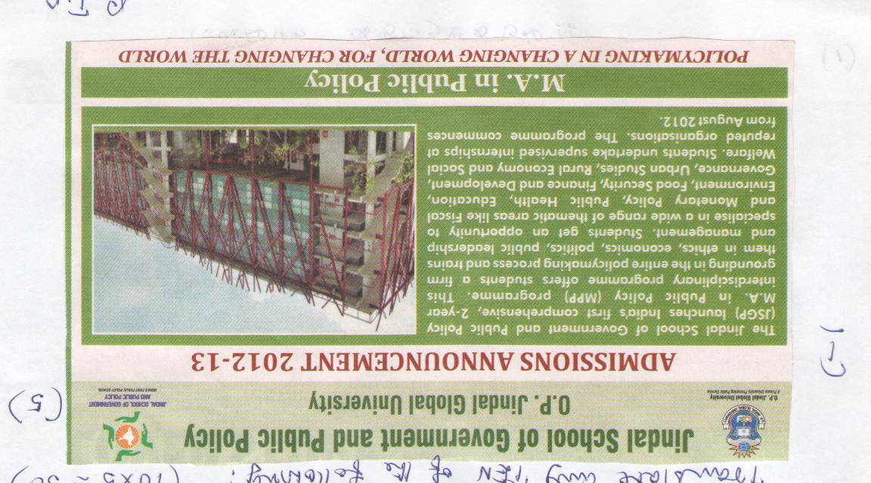
I
5 marks

II Translate the following into Tamil 1 x 5 = 5 marks

III Translate the following into English 1 x 5 = 5 marks
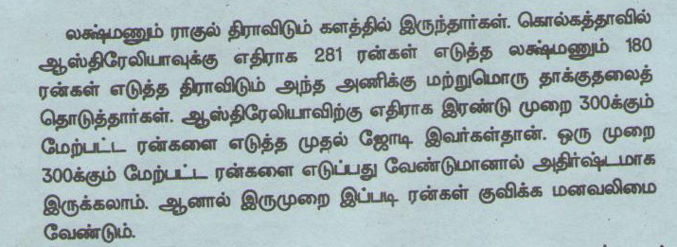

IV Translate the following science text into Tamil 1 x 5 = 5 marks
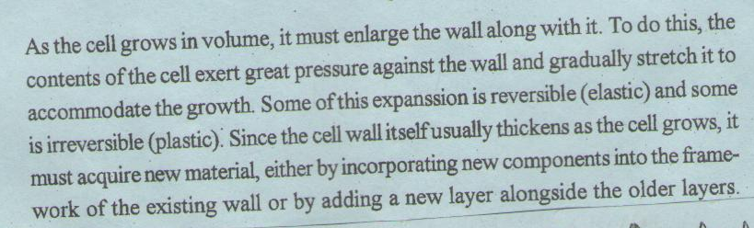

V Translate the following into English 5 x 1 = 5 marks
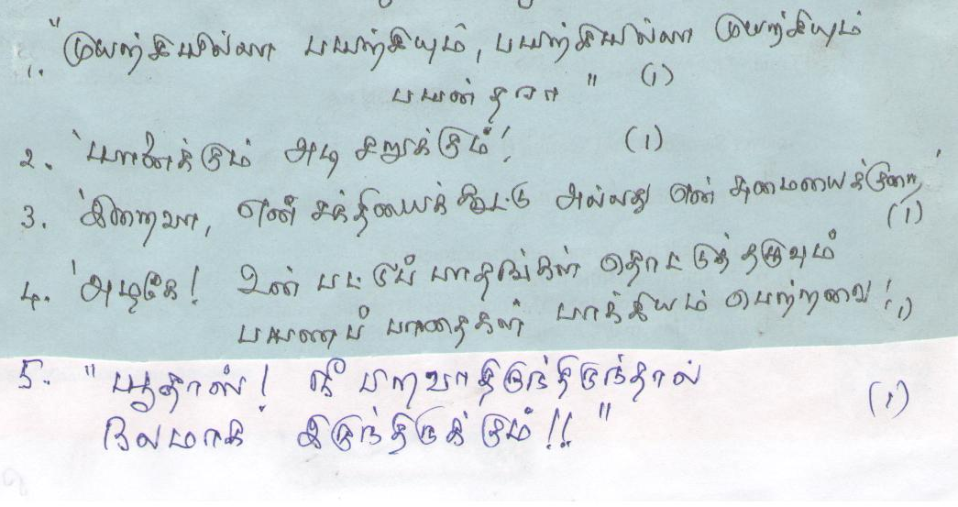

IV Translate into Tamil 1 x 5 = 5 marks
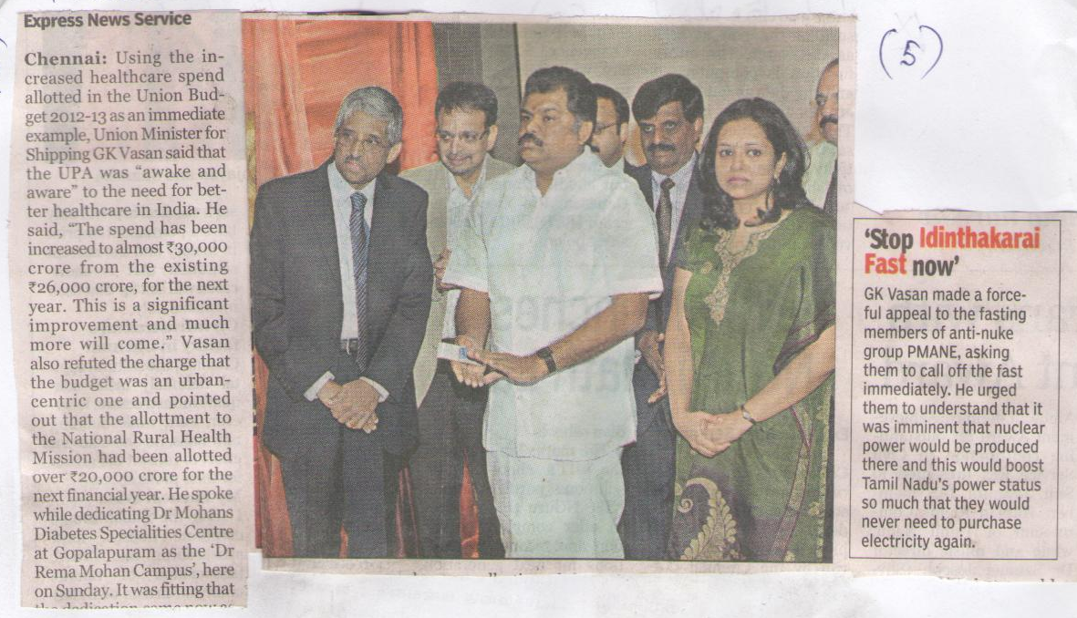

VII Translate the following into English 1 x 5 = 5 marks
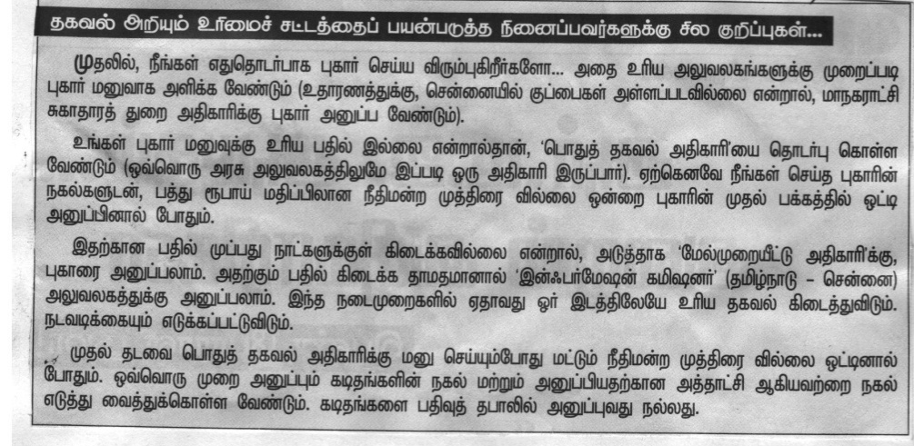

VIII Translate the following into English 1 x 5 = 5 marks

IX Into English ( 5 marks) X Into English (5 marks)

XI Into English ( 5 marks)
XII Into English ( 5 marks)




